Methodological Considerations when Teaching About the Holocaust
Chadron Conference
Guidelines for Teaching the Holocaust and questions to consider. | An indication of your answers
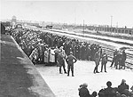
- Define the term "Holocaust"
-Why is it important for students in your classroom to be fully aware of the definition of the term Holocaust?
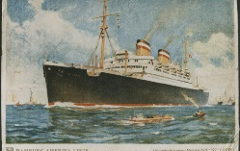
- Do not teach or imply that the Holocaust was inevitable
- Give examples of choices that were made by individuals, groups and nations. Would different choices have resulted in a different outcome?
- Avoid simple answers to complex questions
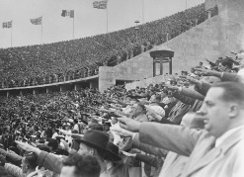
-What are some of the complex ideas, issues, and/or questions students ask and how will you grapple with them?
- Strive for Precision of Language
-Identify specific terms which may need clarification and precision in meaning.
- Strive for balance in establishing whose perspective informs your study of the Holocaust

- What will students learn about the Holocaust from various perspectives of the history?

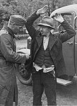
- Avoid comparisons of pain
- How will you keep students from making comparisons?
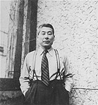
- Do not romanticize history
-How will you keep the balance so as to avoid romanticizing the history?

- Contextualize the history
-Why is it important to have historical context when teaching about the Holocaust?
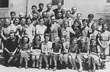
- Translate statistics into people
- What will you look for in a first person account to use in the classroom? Age of individual? Location of his, her story? Time frame of his, her story? Etc.? Which do you feel will be most important to your students and why?
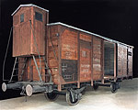
- Make responsible methodological choices
- What steps can you take to seek help in making responsible methodological choices? Why is this extremely important to keep in mind as you handle the topic of the Holocaust in a classroom?

